35.56: a) There is one half-cycle phase shift, so for constructive interference:
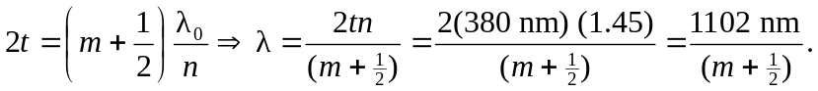
Therefore, we have constructive interference at 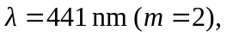 which corresponds to blue-violet.
b) Beneath the water, looking for maximum intensity means that the reflected part of the wave at the wavelength must be weak, or have interfered destructively. So:
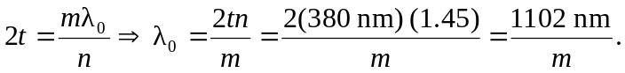
Therefore, the strongest transmitted wavelength (as measured in air) is 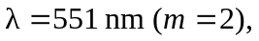 which corresponds to green.

